2026 China Weihai Hobie Open Regatta &
Hobie 16 Asian Championship

International Hobie Class Association North Pacific,
Shandong Province Administration of Sports,
Weihai Major Sports Events Organizing Committee

Organizers: Shandong Maritime Sports Association
Weihai Municipal Sports Bureau
Weihai Sports Federation
Administrative Committee of Weihai TorchHi-Tech Development Zone
June 13rd-14th,2026

Weihai, China

Notice of Race (NoR)
The notation ‘[NP]’ in a rule means that a boat may not protest another boat for breaking that rule. This changes RRS 60.1(a).

RULES

The event is governed by the rules as defined in The Racing Rules of Sailing and the IHCA Class Rules.

No National prescriptions will apply.

SAILING INSTRUCTIONS

The sailing instructions will be available after 16：30 on June 12th at Weihai Linhai Hotel.

communication

The official notice board is located on the Weihai International Beach.

ELIGIBILITY AND ENTRY

The event is open to all boats of the International Hobie Class Association.

Eligible boats may enter by completing the entry form and submitting it.

To be considered an entry in the event, a boat shall complete all registration requirements and pay all fees.

The following restrictions on the number of boats apply: The Local Organizing Committee (LOC) will provide 48 HOBIE-16 sailboats; Participants are allowed to bring their own boats.

fees

Entry fees are as follows:
Class  Hobie 16 | Standard Fee  1,200 CNY entry fee per team
Charter Fee | 1,500 CNY per sailboat.

Other fees: The OC shall charge a separate boat deposit of 2,000 CNY for each sailboat at the registration site. If the leased vessel or important parts are damaged, the leased team shall compensate at the market price.

The entry fee and charter fee shall be paid to the account designated by the LOC by telegraphic transfer or bank transfer.

Account Name: 威海羿洋体育文化传播有限公司

Bank Name: 中国建设银行股份有限公司威海分行

Account Number: 3705 0170 6708 0000 2545

Please note "×× and ×× entry and charter fee" when transferring or telegraphic transfer.

advertising

Boats shall display advertising chosen and supplied by the organizing authority.

Security Boats
Support boats shall be marked with Rescue flag.
Radio Communication Except in an emergency, a boat that is racing shall not make voice or data transmissions and shall not receive voice or data communication that is not available to all boats.

SCHEDULE

Registration:
Date | From | To
June 12th | 9:00 | 15:30

Equipment inspection and event measurement:
Date | From | To
June 12nd | 9:30 | 15:30

Dates of racing:
Date | Time | Hobie 16
June 12nd | 17:30-18:30 | Skippers’ meeting
June 13rd | 8:30-9:00 | Opening ceremony
June 13rd | 9:00-9:15 | Skippers’ meeting
June 13rd | 10:00-16:00 | Racing
June 14th | 8:15-8:30 | Skippers’ meeting
June 14th | 9:00-15:00 | Racing
 | 15:00-17:00 | Boat inspection
 | 17:30-20:00 | Award ceremony

Number of races:
Class | Number | Races per day scheduled
Hobie 16 | 8 | 4

The scheduled time of the warning signal for the first race each day is 10:00.

On the last scheduled day of racing no warning signal will be made after 15:00.

EQUIPMENT INSPECTION

[DP] Boats shall be available for equipment inspection from June 12nd, 13:00.

Boats may be inspected at any time.

The following equipment may be inspected or measured:

(1). Hull dimensions and corrosion-proof certification.

(2). Sail area compliance and prohibited materials.

[DP] non-compliant items may lead to penalties.

[DP] Boats shall also comply with RRS 78.1.

clothing and equipment

A competitor’s clothing and equipment shall not weigh more than 10 kilograms, as permitted by RRS 50.1(b).

The minimum combined crew weight of a Hobie 16 shall be 285 lbs. (129.3 KG). Weights shall be carried on the boat to bring crew weight up to the minimum crew weight.

VENUE

The NoR Addendum I shows the plan for the event venue.

courses

The course(s) to be sailed will be as follows: Standard IHCA Course

The marks that may be used are described in the SIs.

PENALTY SYSTEM

For the Hobie 16 class RRS 44.1 is changed so that the Two-Turns Penalty is replaced by the One-Turn Penalty.

The intention is to appoint a national jury as provided in RRS 70.5.

The right of appeal from a protest committee decision is denied as provided in RRS 70.5.

scoring

The scoring system is as follows: Low Scoring Method Appendix A in RRS

One race are required to be completed to constitute a series

A boat’s series score shall be the total of her race scores.

When fewer than four races have been completed, a boat’s series score will be the total of her race scores

When from 5 or more races have been completed, a boat’s series score will be the total of her race scores, excluding her worst score

Rule A5.3 applies.

SUPPORT PERSON VESSELS

15.1 [DP] Support person vessels shall be marked with ‘H’® flag.

chartered or loaned boats

A chartered or loaned boat may carry national letters or a sail number in contravention of her class rules, provided that the race committee has approved her sail identification before the first race.

BERTHING

[DP] Boats shall be kept in their assigned places while in the boat park.

MEDIA RIGHTS, CAMERAS AND ELECTRIC EQUIPEMENT

By participating in the event each competitor automatically grants to the Organizing Authority, and their sponsors the right in perpetuity to make, use and show, from time to time at their discretion, any motion pictures and live, taped or filmed television and other reproductions of the athlete and their equipment during the period of the competition, without compensation.

Boats may be required to carry cameras, sound equipment or positioning equipment as

specified and provided by the Organizing Authority.

Competitors may be required to be interviewed during the event.

RISK STATEMENT

RRS 3 states: ‘The responsibility for a boat’s decision to participate in a race or to continue to race is hers alone.’ By participating in this event each competitor agrees and acknowledges that sailing is a potentially dangerous activity with inherent risks. These risks include strong winds and rough seas, sudden changes in weather, failure of equipment, boat handling errors, poor seamanship by other boats, loss of balance on an unstable platform and fatigue resulting in increased risk of injury. Inherent in the sport of sailing is the risk of permanent, catastrophic injury or death by drowning, trauma, hypothermia or other causes.

INSURANCE

Each participating boat shall be insured with valid third-party liability insurance with a minimum cover of 900,000 CNY per incident or the equivalent.

prizes

Prizes will be given as follows:
（1）Open group
The top 8 winners will be awarded 65,000 CNY in total. Prizes will be given as follows:
RANK | AWARD | RANK | AWARD
Winner | 20,000 CNY | 5th Place | 5,000 CNY
2nd Place | 15,000 CNY | 6th Place | 4,000 CNY
3rd Place | 10,000 CNY | 7th Place | 3,000 CNY
4th Place | 6,000 CNY | 8th Place | 2,000 CNY
If the registered teams are less than or equal to 10 teams (6-10 teams), the admission ranking will be reduced by 3.
If the number of registered teams is less than or equal to 5 (4-5 teams), only the first place will be admitted.
If the number of registered teams is less than or equal to 3, no ranking will be accepted.
The above prizes are pre-tax bonuses. The first eight places will be awarded trophies.
（2）The Master's group award the top three with trophies, no prize money is provided.
（3）All participants will be awarded with commemorative medals..

FURTHER INFORMATION

For further information will be displayed in the supplementary notice.
SAFETY
Sailors are strongly recommended to use trapeze harnesses with a quick release hookless system or a quick release hook, which meets the ISO 10862 standard.

HELMETS
If sailors wish to wear head protection it is strongly recommend, they use helmets of European standard EN1385.
ELECTRICAL POWER LINES – AVOID!!!
Before raising the mast, and always while sailing, check for and avoid low overhead electrical power lines. If you see a power line, AVOID IT! A MAST COMING IN CONTACT OR EVEN NEAR AN ELECTRICAL POWER LINE CAN CAUSE SERIOUS INJURY OR DEATH TO PEOPLE ON OR TOUCHING THE BOAT!

Addendum I

Regatta Course Map
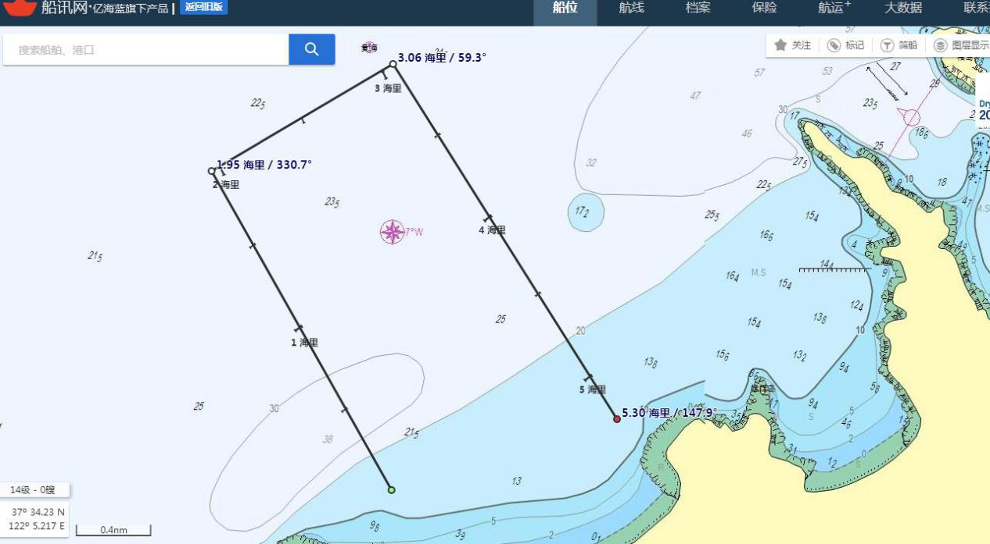
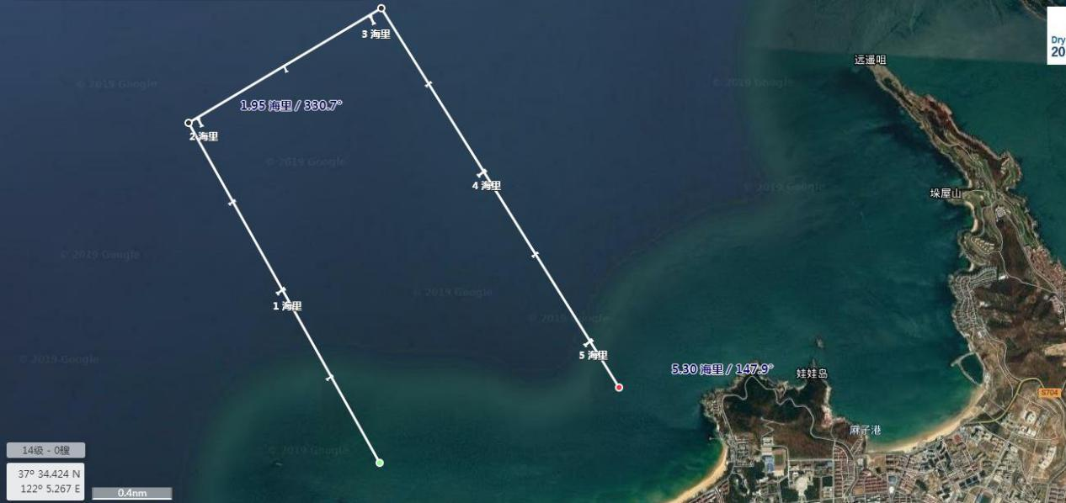
The reference coordinates of the racing area:
(1)N 37° 33.738, E122° 00.309;
(2)N 37° 31.889, E122° 01.318;
(3)N 37° 34.054, E122° 01.251;
(4)N 37° 32.217, E122° 02.415.
Addenmum II

Entry Form (Team: *)
Division |  |  | Boat Rental | □ Rental / □ Bring Your Own
Position | Helm | Name |  | Gender
Nationality |  | Date of Birth | YYYY/MM/DD) | Weight | KG
ID Type |  | ID Number
Health Status |  | Health Notes | Blood type, allergies, or special notes for the committee
Employer & Position |  |  | E-mail
Mobile Number |  |  | Emergency Contact
Key Sailing Experience & Achievements:

Position | Crew | Name |  | Gender
Nationality |  | Date of Birth | YYYY/MM/DD | Weight | KG
ID Type |  | ID Number
Health Status |  | Health Notes | Blood type, allergies, or special notes for the committee
Employer & Position |  |  | E-mail
Mobile Number |  |  | Emergency Contact
Key Sailing Experience & Achievements:

Additional Information
Arrival Time | Exact Date & Time | Arrival Location | Airport/Station/Port | Station/Stop Number | Flight/Train No.
Departure Time | Exact Date & Time | Departure Location | Airport/Station/Port | Station/Stop Number | Flight/Train No.
Room Type & Quantity |  | Check-in Date |  | Check-out Date
Addendum III
Accommodation and travel

Transportation Expense
The transportation expense shall be borne by the competitors.

Accommodation Expenses

1) Accommodation booking information will be provided before June 3st. The Organizing Committee provides discounted accommodation and dining options:
LINHAI Hotel
standard room or king-size room: Around 300 RMB/day
All room rates include breakfast, with check-out before 2:00 PM.

- The Organizing Committee will provide lunch during the races. The awards ceremony dinner is also included.

